# Quality check

(a) Quality assessment on Loan_Amount_000 and Respondent_Name

We define those loans whose loan amount greater than (75% quantile + 3*inter quantile range of all loans) in its’ own MSA or MD area are the statistical outlier, these loans are regarded as large loan and could be of poor quality. (saved in the data frame ‘large_loan_byMSA’).

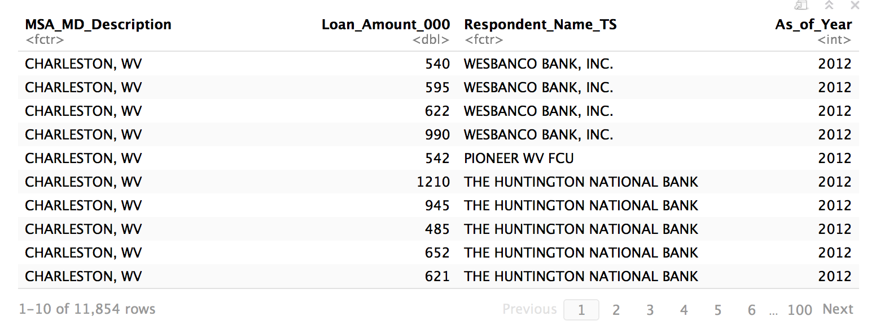

The data frame ‘large_loan_byRespondent’ then shows the total number of those large loans owned by each respondent.

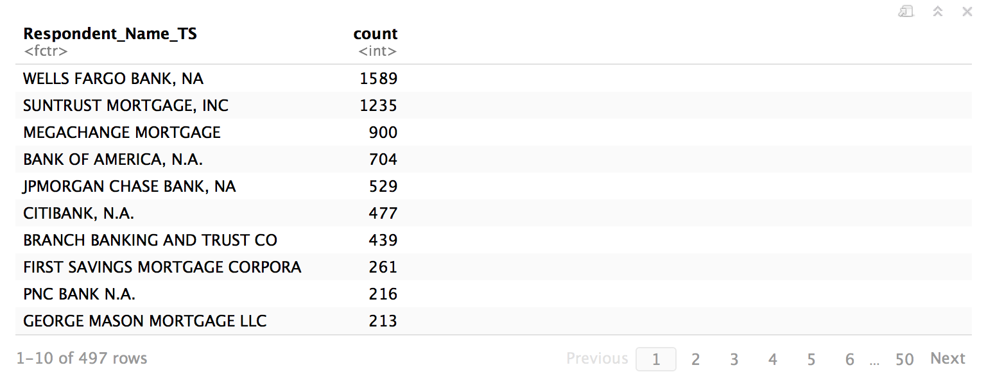

Loan to income ratio (Loan_Amount_000/Applicant_Income_000) would also be an important column because this reflects applicant's ability to pay back.

The critical value for statistical outliers for the loan to income ratio equals to 8.69 (75% quantile + 3*inter quantile range). Which means the applicant will not be able to pay back the principal in almost nine years’ time, we assume these loans as risky loans. We found those loans and saved in the data frame ‘risky_loan’. These loans are regarded as the risky loans.

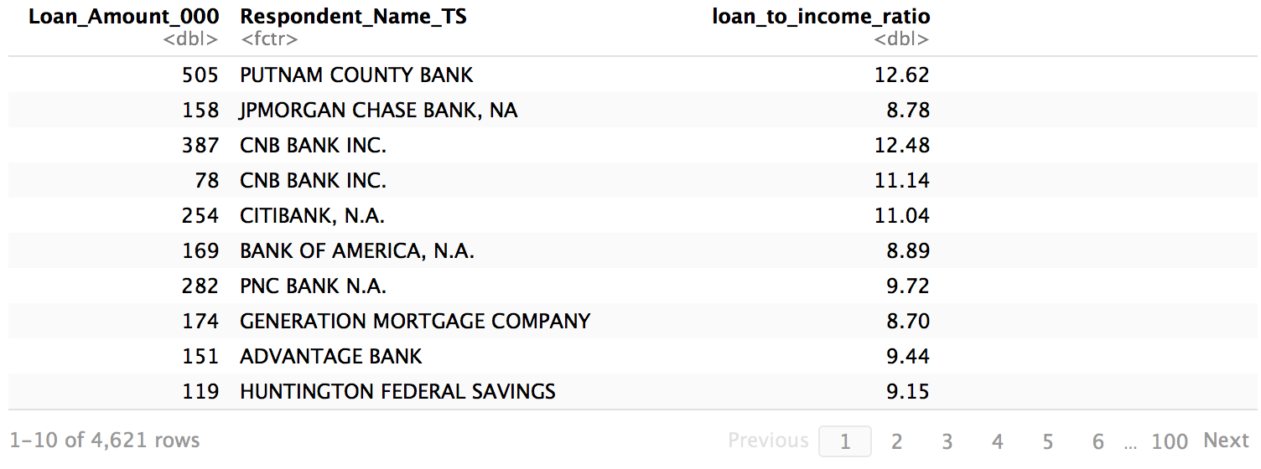

The data frame ‘risky_loan_byRespondent’ then shows the total number of those risky loans owned by each respondent.

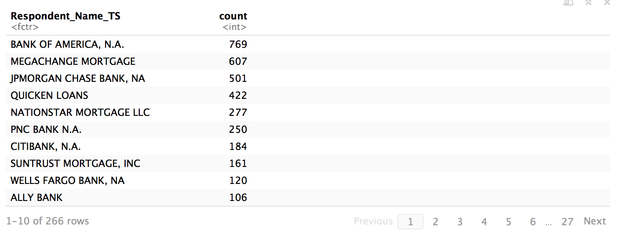

Combine (a) and (b), we then found those loans that are both large and risky, saved in data frame ‘large_risky_loan’. These loans are regarded as poor quality loans.

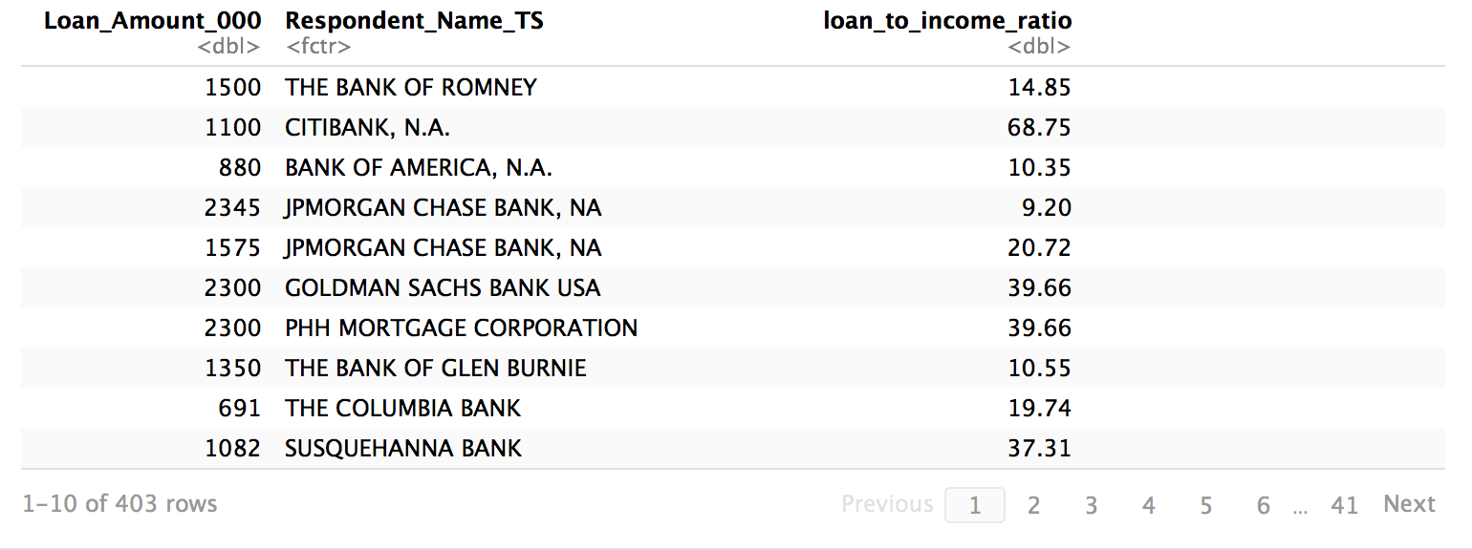

We thought there should be a big intersection between large loans and risky loans. However, there are 11,854 large loans and 4,621 risky loans, and only 403 risky large loans. Which means only around 10% of risky loans are from large loans. The data frame ‘risky_loan_distribution’ shows the distribution of risky loans in different loan groups:



The table shows that almost 60% of risky loans come from the middle group of loan! These statistics demonstrate that loan amount is not always correlated with risk. For example, jumbo loans are intended for excellent borrowers with excellent credit looking to finance loan amounts greater than the amount allowed by Fannie Mae or Freddie Mac, according to our findings, jumbo loans are not having to be more risker than conforming loans.

The market size for the jumbo market is the only market that shrinks slowly, and our quality assessment shows that most of the risky loans are coming from the middle group of loans. Therefore, my recommendation for any company that want to enter this home loan market could focus its business on the jumbo market.